Team ID: CU_CP_Team_9434 Submitted by:
Tanisha Majmundar
Riaan Sendhav
Vanshika Mehta

DISHCOVERY – Your Cooking Assistant

PROBLEM STATEMENT
Meal planning is a daily challenge for many individuals, particularly when limited to the ingredients currently available at home. The traditional method of browsing countless recipes online is inefficient and lacks personalization. This results in decision fatigue, repetitive meals, and often leads to food wastage.
There is a pressing need for a smart and efficient solution that can:
- Understand what ingredients a user has,
- Identify dietary preferences or restrictions, and
- Suggest appropriate recipes instantly.
This project aims to address this need through the development of an AI-powered Recipe Suggestion Website called Dishcovery, which uses user-inputted ingredients to recommend tailored, easy-to-make recipes.

PROJECT OVERVIEW
Dishcovery is a user-friendly web application that recommends recipes using machine learning techniques. It takes user-inputted ingredients and applies CountVectorizer to convert them into vectors, then uses the K-Nearest Neighbors (KNN) algorithm to find the most relevant recipe matches.
This simple and effective approach helps reduce food waste, encourages variety in cooking, and saves users time in deciding what to prepare.

OBJECTIVES
- Develop a responsive web application that suggests recipes based on available ingredients.
- Apply machine learning (KNN + CountVectorizer) to match user inputs with relevant recipes.
- Enhance user experience with features like search, filters, and recipe cards.
- Enable future scalability with analytics and personalization options.

TARGET END USERS
The project is aimed at a wide range of users:
- Home Cooks who want to prepare meals using on-hand ingredients.
- Students and Working Professionals who require quick, easy recipes with limited resources.
- Beginner Cooks who benefit from guided steps and minimal effort.
- Health-conscious Users who want to make better food choices without browsing for hours.

PROPOSED SOLUTION
Dishcovery is an AI-driven recipe recommendation system with a MERN-based interface and cloud-ready backend. Users input ingredients, which are vectorized using CountVectorizer. The system applies KNN to find and rank recipes based on similarity.
Suggested recipes include:
- Cooking time
- Dish type
- Step-by-step instructions
- Tips/variations
- Images (if available)
Search and filtering enhance usability for exploring dish types or names.

SYSTEM ARCHITECTURE & WORKFLOW
Dishcovery is designed with a modular and scalable architecture that ensures performance, simplicity, and user-friendliness. The core components of the system include:
Architecture Overview
- Frontend:
Developed using HTML, CSS, and JavaScript for responsive and intuitive user interfaces.
- Backend:
Built with Node.js and Express.js, handling API calls, model integration, and database operations.
- Database:
MongoDB is used for storing recipe data, user accounts, and activity logs.
- Machine Learning Layer:
  - Developed in Python
  - CountVectorizer is used for converting recipe ingredients into numerical vectors
  - K-Nearest Neighbors (KNN) algorithm is used to find recipes with ingredient similarity
- Data Analytics Module:
Built using Pandas, Matplotlib, and Seaborn for generating insights and charts on usage, cuisine popularity, etc.

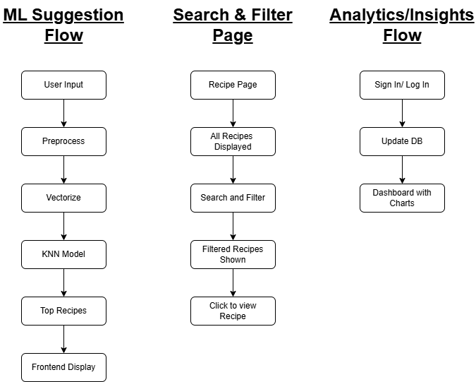
FUNCTIONAL WORKFLOW
The diagram represents the complete functional workflow of the Dishcovery system:
This flow is divided into three logical lanes:
- User Interaction and Recipe Recommendation: Users input ingredients, which are preprocessed, vectorized, and passed through the KNN model to fetch top recipe matches.
- Browsing and Filtering Recipes: Users can search, apply filters, and view detailed recipe pages.
- Admin & Dashboard Access: Admin users can log in, update the recipe database, and view analytics charts based on recipe usage.

RESULTS
The developed system was tested with a range of user inputs. It successfully:
- Suggested relevant recipes based on provided ingredients.
- Displayed complete cooking instructions in an easy-to-read format.
- Offered suggestions in under 2 seconds per request.
The system also allowed filtering by dish type and searching by name, enhancing its usability and user engagement.

CONCLUSION
Dishcovery effectively meets the objectives of a modern-day cooking assistant. It intelligently recommends recipes, simplifies decision-making, and introduces users to new dishes. Through machine learning and web development integration, this system not only solves a practical problem but also serves as a scalable project for further innovation in the food-tech domain.
Its user-first design, coupled with intelligent features, makes it a promising tool for anyone struggling with “What to cook today?”

